**ANNEX A**

***CHECKLIST OF SUPPORTING DOCUMENTS***

***OF MUTUAL BENEFIT ASSOCIATIONS***

***For The Year Ended 31 December 2022***

**_____________________________________________________________**

**NAME OF ASSOCIATION**

| **DOCUMENT** | | | **SOFT COPY** | |
| --- | --- | --- | --- | --- |
| **PDF File** | **Excel File** |
|  | 1. | 2022 Audited Financial Statements with comparative figures for 2021, signed by an External Auditor accredited by the Insurance Commission, and duly received by the Bureau of Internal Revenue (BIR) |   ✓  *(Whole AFS- strictly PDF File converted from Excel and Word File, to enable CTRL F function)*  ✓  *(Scan copy of the stamped received by BIR)* |  |
|  | 2. | 2022 General Information Sheet filed with Securities and Exchange Commission **if with changes or updates** |  |  |
|  | 3. | External Auditor Report (Management Letter Points, Management Letter of Comments, Management Letter to Recommend, Summary of Internal Control Deficiencies or Management Letter separate from the Opinion page) as of 31 December 2022 | ✓ |  |
|  | 4. | Accredited actuary’s certification on actuarial and all related accounts / Statement of Opinion on Policy Loans *(e.g. Basic contingent benefit reserve, Optional benefit reserve, Liability on individual equity, Membership certificate loans****/****Policy loans, Member's contributions/premiums due & uncollected, Members' assessment receivable, Claims payable on basic contingent benefit/Optional benefits)* |  |  |
|  | 5. | Certification of the Association's comptroller or any responsible officer with the rank of at least Vice President for the accounts: *Members' fees &, dues receivable, Liability on individual equity, Unremitted members’ contributions, dues & fees, Unremitted premiums, Members' deposit, Capital Deposits, Capital Equity or any similar deposit (if any), Members' contributions/premiums received in advance, Retirement Savings Fund, Loan Liquidation Fund, or any similar fund (if any)* |  |  |

|  |  |  |  |  |
| --- | --- | --- | --- | --- |
|  | 6. | Detailed schedule of the following actuarial accounts (with PDF copies of the (i) First Page and (ii) Last Page (**Showing the totals of the said schedules and submit the reconciliation of discrepancy between the schedule and balance per AS**): |  |  |
|  |  | 1. Seriatim List of all members indicating therein the minimum basic information using the attached format  **(MBA REQUIRED Format No.01)** |   *(First Page and Last Page only of* ***ALL*** *the required schedules)* |   *(Excel File of* ***ALL*** *the required schedules)* |
|  |  | 1. Unremitted members’ contributions, dues & fees and Unremitted premiums indicating therein the minimum basic information :   *Membership certificate/Policy number, Name of Member/Policyholder, Membership/Policy Date, Basic benefit, Amount of Insurance, Due Date of unremitted contribution, dues & fees/premium paid by member, Unremitted members’ contribution, dues & fees, /Unremitted premiums as of 31 December 2022, Equity value as of 31 December 2022; Policy Reserves as of 31 December 2022, Date of remittance to Association in year 2022.* |
|  |  | 1. Claims payable on basic contingent benefit, Claims payable on optional benefit, Other benefit payable on Basic/Optional policies as of 31 December 2022 duly signed by General Manager/Claims Manager  **(MBA REQUIRED Format No. 02)** |
|  |  | 1. All claims filed (paid or unpaid) for Basic & Optional insurance in the first quarter of 2023 indicating therein the minimum information same in requirement 6.c |
|  |  | 1. Members’ contributions received in advance/Premiums received in advance indicating therein the minimum basic information **(MBA REQUIRED Format No. 03)** |
|  |  | 1. Members’ Deposits, Capital Equity Deposits, Capital Contribution, Retirement Savings Fund, Loan Liquidation Fund or any similar account indicating therein the minimum basic information: **(MBA REQUIRED Format No. 04)** |  |  |
|  | 7. | Claims paid/denied during the year  **(MBA Format No. 05A & 05B)** |  |  |
|  | 8. | Summary of in-force certificates and policies by plan of insurance as of 31 December 2022  **(MBA Format No. 06)** |  |  |
|  | 9. | Copy of latest approved IRR and Membership Certificate for both Basic and Optional Insurance |  |  |
|  | 10. | Sales Invoices and Official Receipts to support purchases of Information Technology (IT) Equipment during the year ended 31 December 2022 |  |  |
|  | 11. | Actuarial Valuation Report as of 31 December 2022 of Pension Asset/ Obligation Account and related supporting documents for the Plan Assets Account. | ✓ |  |
|  | 12. | Minutes of Meetings of the Board and Executive Committees, including a copy of Board Resolutions made during the year ended 31 December 2022 |  |  |
|  | 13. | Latest copy of Certificate of Tax Exemption issued by the Bureau of Internal Revenue (BIR) pursuant to BIR Revenue Memorandum Order No. 38-2020 |  |  |
|  | 14. | **General Reminders:**   1. To avoid, penalty due to wrong data entry pursuant to IC CL No. 2014-15, the Association should completely and properly fill out applicable schedules in the Annual Statement. 2. For uploading of supporting documents in the online uploading system via <https://onuploading.insurance.gov.ph/templates/login>, the following must be segregated: b1. Items Nos. 6,7,8, & 9 must be uploaded in the *Actuarial Requirements* sub-folder.   b2. All other items EXCEPT items stated in Item no. 14(b1) must be uploaded in the *Financial Requirements* sub-folder. |  |  |

|  |  |  |  |  |  |  |
| --- | --- | --- | --- | --- | --- | --- |
|  |  | . |  | . |  | . |
|  | ***Remarks:*** |  |  |  | ***Submitted by:*** |  |
|  |  |  |  |  |  |  |
|  |  |  |  |  |  |  |
|  |  |  |  |  | *Signature over Printed Name* |  |
|  |  |  |  |  |  |  |
|  |  |  |  |  |  |  |
|  | ***Received by:*** |  |  |  | *Designation* |  |
|  |  |  |  |  |  |  |
|  |  |  |  |  |  |  |
|  | *Signature over Printed Name* |  |  |  |  |  |
|  |  |  |  |  |  |  |
|  |  |  |  |  |  |  |
|  | *Designation* |  |  |  |  |  |
|  |  |  |  |  |  |  |



20xx

20xx

20xx

Dec 20xx

31 December 20xx

Seriatim List of Members as of December 2022

**MBA FORMAT NO. 01**



xxXX

Name of Association: ____________

As of 31 December 2022

**MBA FORMAT NO. 02**

_______________

Manager’s Signature



Name of Association

Schedule of Contribution/Premiums Received in Advance

As of 31 December 2022

**MBA FORMAT NO. 03**

**MBA FORMAT NO. 04**

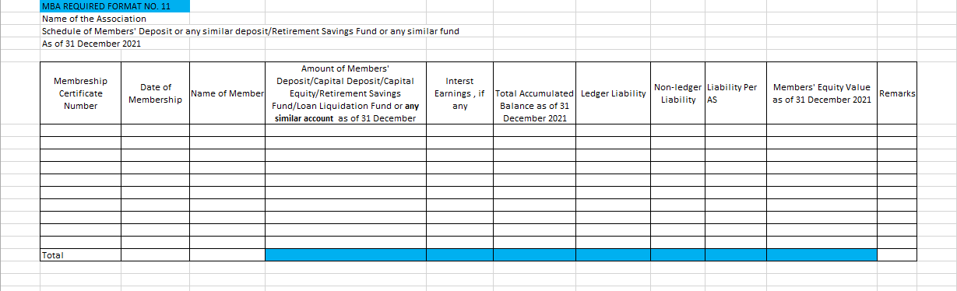

xxXX

xxXX

xxXX



xxXX



**CLAIMS DENIED DURING THE YEAR 20xx**

xxXX

**MBA FORMAT NO. 06**

