**ANNEX A**

**CHECKLIST OF SUPPORTING DOCUMENTS**

**OF LIFE INSURANCE COMPANIES**

**For The Year Ended 31 December 2022**

**____________________________________________________________**

**NAME OF COMPANY**

|  |  | **DOCUMENT** | **SOFT COPY** | | |
| --- | --- | --- | --- | --- | --- |
| **PDF File** | **Excel File** |
|  | 1. | 2022 Audited Financial Statements (AFS) with comparative figures for 2021, signed by an External Auditor accredited by the Insurance Commission, and duly received by the Bureau of Internal Revenue (BIR).  Composite Insurance Companies, should present a separate Statement of Financial Position and Statement of Comprehensive Income for each unit or segment (Life and Non-Life), either at the face or notes of the AFS. | ✓  *(Whole AFS- strictly PDF File converted from Excel and Word File, to enable CTRL F function)*  ✓  *(Scan copy of the stamped received by BIR)* |  |
|  | 2. | Computation of Amended Risk-based Capital Ratio (RBC2) of the company. |  | ✓ |
|  | 3. | External Auditor Report (Management Letter Points, Management Letter of Comments, Management Letter to Recommend, Summary of Internal Control Deficiencies or Management Letter separate from the Opinion page) as of 31 December 2022. | ✓ |  |
|  | 4. | 2022 General Information Sheet (GIS) filed with Securities and Exchange Commission (SEC) *if with changes or updates*. | ✓ |  |
|  | 5. | 1. Actuarial Valuation Report (AVR) as of 31 December 2022 pursuant to IC Circular Letter (CL) No.2016-66; 2. AVR Analysis using Annex B; 3. Certification on the balances of all actuarial accounts and a Statement of Opinion on Policy Loans by the company’s Actuary duly accredited by the Insurance Commission per IC CL No. 3-87; 4. Certification on Premium Deposit Fund (PDF) by the company’s comptroller or any responsible officer with the rank of at least Vice President; and 5. Statement of Account/Certification from Pools account as of 31 December 2022. | ✓  (*Except for item B)* |  ✓  (*For item B Only)* |
|  | 6. | Detailed schedule of the following actuarial accounts (with PDF copies of the (i) First Page and (ii) Last Page (***showing the Totals of the said schedules***) and submit the reconciliation if there are discrepancies noted: |  |  |
|  |  | 1. Seriatim List of all Policyholders indicating therein the minimum basic information using the attached Life – Required Format No. 1 and Reconciliation of Reserves –Life Required Format No. 2; | ✓  *(First Page and Last Page only of* ***ALL*** *the required schedules)* | ✓  *(Excel File of* ***ALL*** *the required schedules)* |
|  |  | 1. Policyholder’s Due & Unpaid and Policyholders’ Dividends Accumulations/Dividends Held on Deposit indicating therein the minimum basic information:   (*Policy Number, Policy /Effectivity Date, Plan, Amount of Insurance, Maturity Date, Amount of Dividends due & Unpaid (a. Dividends for policyholders b. Experience refund) Amount of Dividend Accumulations/held on deposit, Gross Premium Reserves as of 31 December 2022;* |
|  |  | 1. Policy & Contract Claims Payable as of 31 December 2022, and schedule of all claims filed paid or unpaid for the 1st Quarter of 2023 indicating therein the minimum basic information   (*Date Filed, Date of Death/Hospitalization/Accident, Claim Number* ,*Policy Number, Policyholder’s name, Policy /Effectivity Date, Maturity Date, Plan, Amount of Insurance, Amount of Claim, Amount paid, Date paid, Unpaid/Outstanding Claims as of 31 December 2022, Status/Remarks);* |
|  |  | 1. Schedule of the asset/s that corresponds and identifies Premium Deposit Fund and/or contingency fund, future funds, benefit enhancement funds & similar fund (if any) as per IC CL No. 2014-27 dated 05 June 2014; |
|  |  | 1. Aging of Unclaimed Benefits (Due & Unpaid/ Outstanding Claims/ Maturities & Surrenders per sheet) using the attached Life- Required Format No. 3; and |
|  |  | 1. Claims paid/denied during the year (Life Format Nos. 3-A and 3-B). |
|  | 7. | Memorandum of Agreement between the IC-regulated entity and DepEd if applicable. | ✓ |  |
|  | 8. | Sales Invoices and Official Receipts to support purchases of IT Equipment during the year ended 31 December 2022. | ✓ |  |
|  | 9. | AVR of Pension Asset/ Obligation Account and related supporting documents for the Plan Assets Account. | ✓ |  |
|  | 10. | Conglomerate Map *if with updates* from the previous year’s submissions. | ✓ |  |
|  | 11. | Official Receipts to support payments of Premium Tax, Documentary Stamps Tax and Real Estate Tax during the year ended 31 December 2022. | ✓ |  |
|  | 12. | Letter of Assessment (LOA) from BIR Tax Assessment and proof of payments (BIR Form No. 0605). | ✓ |  |
|  | 13. | For companies with Variable Contracts:  Separate Annual Statement for each Variable account. |  | ✓ |
|  | 14. | Minutes of Meetings of the Board and Executive Committees, including a copy of Board Resolutions made during the year ended 31 December 2022. | ✓ |  |
|  | 15. | Certification/Confirmation from Reinsurers of the outstanding balance of reinsurance account as of 31 December 2022. | ✓ |  |
|  | 16. | **General Reminders:**   1. *To avoid, penalty due to wrong data entry pursuant to IC CL No. 2014-15, the Company should completely and properly fill-out applicable schedules in the Annual Statement; and* 2. *For uploading of supporting documents in the online uploading system via* [*https://onuploading.insurance.gov.ph/templates/login*](https://onuploading.insurance.gov.ph/templates/login)*, the following must be segregated:*   *b.1. Item Nos. 5 & 6 must be uploaded in the Actuarial Requirements sub-folder.*  *b.2. All other items EXCEPT items stated in Item No. 16 (b.1) must be uploaded in the Financial Requirements sub-folder.* |  |  |
|  |  |  |  |  |

|  |  |  |  |  |  |  |
| --- | --- | --- | --- | --- | --- | --- |
|  |  | . |  | . |  | . |
|  | **Remarks:** |  |  |  | **Submitted by:** |  |
|  |  |  |  |  |  |  |
|  |  |  |  |  |  |  |
|  |  |  |  |  | Signature over Printed Name |  |
|  |  |  |  |  |  |  |
|  |  |  |  |  |  |  |
|  | **Received by:** |  |  |  | Designation |  |
|  |  |  |  |  |  |  |
|  |  |  |  |  |  |  |
|  | Signature over Printed Name |  |  |  |  |  |
|  |  |  |  |  |  |  |
|  |  |  |  |  |  |  |
|  | Designation |  |  |  |  |  |
|  |  |  |  |  |  |  |

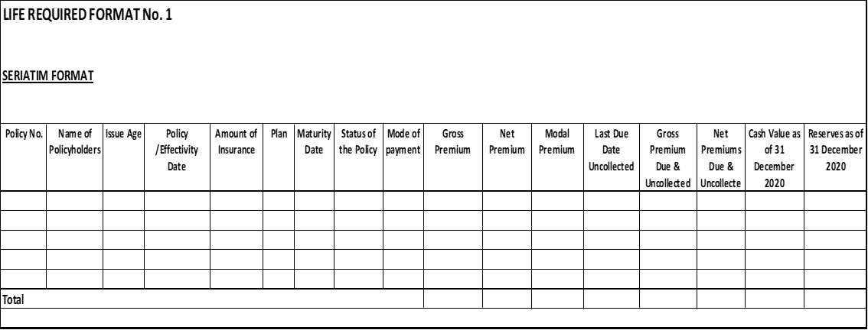

**LIFE FORMAT No. 1**

**Format No. 2**

**Name of Company**

**Reconciliation of Policy Reserves/Premiums Due & Uncollected Reconciliation**

**As of December 31, 20____**

**Per AS (SFP)**

**Per Seriatim**

*(Page 3, Line 25 + Line 26)*

**Ex.**

Individual

Health

Group

VUL

Less: Reinsurance Reserves

**Total**

**Type of Business**

**Per Actuary's Certification**



**3**

20xx

**FORMAT NO. 3-A**

**NAME OF LIFE INSURANCE COMPANY**

Claims Paid during the Year 2022

Microinsurance

**Total**

xxxxxxxxxxx.xx

xxxxxxxxx.xx

**Date of Loss**

**Date of**

**Hospitalization**

**Date Filed (**

***With***

***Complete documents)***

**Amount Paid**

**Date Paid**

**Claims Status**

**Product/Plan**

**Nature of**

**Claim**

**Name of**

**Assured**

**Name of**

**Beneficiary**

**Sum**

**Insured**

**Amount of**

**Claim**

XX

**Format No. 3-B**

**NAME OF ASSOCIATION LIFE INSURANCE COMPANY**

Denied Claims during the Year 2022

Microinsurance

**Total**

xxxxxxxxxxx.xx

**Date of**

**Loss**

**Date of**

**Hospitalization**

**Date Filed (**

***With***

***Complete documents)***

**Date**

**Denied**

**Claims Status**

**Product/Plan**

**Nature of**

**Claim**

**Name of**

**Beneficiary**

**Name of**

**Assured**

**Sum**

**Insured**

**Amount of**

**Claim**