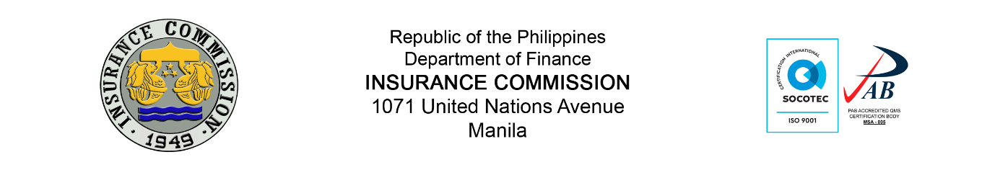
Online Submission (Statistics and Research Division) – Form 1
- Type of Report
- EQRSFS | - Catastrophe/Property Insurance Report (DRFI)

- Type of Request:
- New Account | - Update Account Information
- Reactivate | - Deactivate

- Supporting Documents:
- Authorization Letter signed by Manager or Head
- Copy of Government-issued ID

- Company Representative

Last Name:
Middle Name:
First Name:
Company:
Branch (e.g. Manila):
Department/Division:
Position:
Valid company employee official email address:
Signature:
Please use additional sheet for additional company representative.
The information you provide will be treated with utmost respect and confidentiality. The Insurance Commission follows general principles and rules of Data Privacy protection in the Philippines.
Please wait for an email confirmation for your user credentials.
Authorization:
The above enumerated information has been authorized by this company in relation to the transaction with the Insurance Commission (IC) on matters pertaining to the Online Submission System. It is my responsibility to immediately inform IC by filing the necessary information on eventuality of any change and/or modification covering this authorization, including amendment/s to any of the information.
Printed Name and Signature of Authorized Officer (please indicate your position below the line):

